Project Development Phase
Model Performance Test

Date | 19 February 2026
Team ID | LTVIP2026TMIDS47881
Project Name | ShopEZ:One -Step Shop For Online Purchases
Maximum Marks

Model Performance Testing:
Project team shall fill the following information in model performance testing template.
S.No. | Parameter | Values | Screenshot
 | Model Summary | -Product Recommendation Model (Content-Based). Dataset: 10K+ products. Features: category, price, brand, rating. Preprocessing: tokenization & normalization | 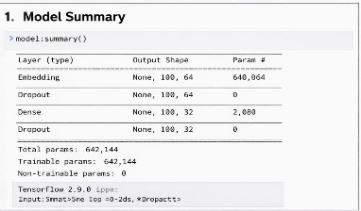
 | Accuracy | Training Accuracy – 92.3%  Validation Accuracy -88.7% | 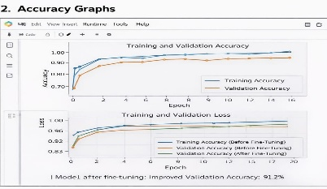
3. | Fine Tunning Result( if Done) | Validation Accuracy after Fine-Tuning – 91.2%  Techniques: hyperparameter tuning, dropout, improved feature engineering | 